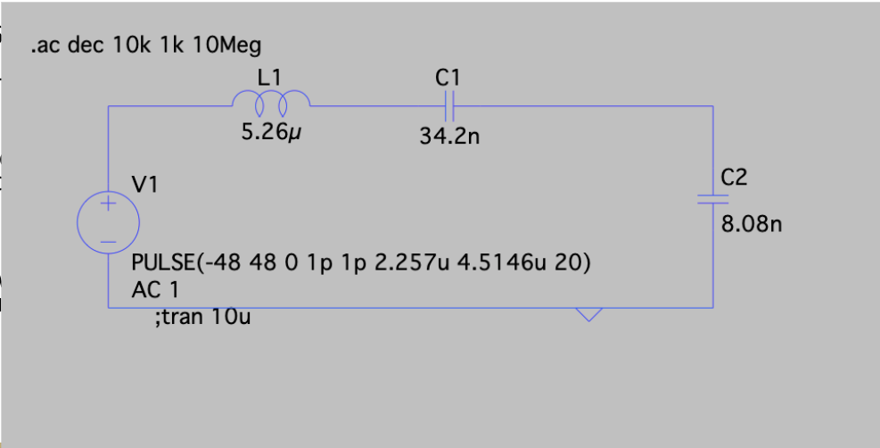

* C1 has 4 parallel footprints
* C2 has 2 parallel footprints

**Current calculations:**

$I_{sc}RMS=5A$

$d=0.25$

$n_{ratio}=2.5$

Accounting for 10% variable swing

$I_{sc}RMS=5.5A$

$I_{sc}RMS (Primary) = 5.5*n=> 5.5*2.5=13.75A$

Accounter for 25% Duty cycle

$I RMS (Primary) 13.75A*0.25=3.4375A$

**Calculations for C1:**

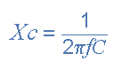

<https://www.electronics-tutorials.ws/filter/filter_1.html>

<https://www.electronics-tutorials.ws/dccircuits/current-divider.html>

By current division:

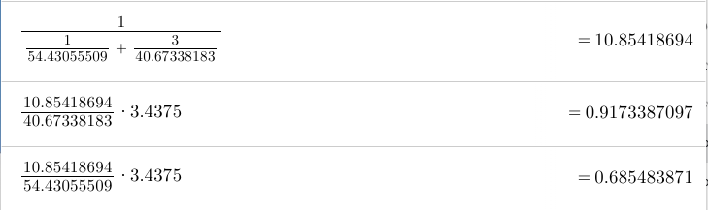

* **0.9173A through 9100pF capacitors**
* **0.6855A through 6800pF capacitors**

**Calculations for C2:**

$C_{2}(1)=3900pF$

$C_{2}(2)=4300pF$

**(The choice behind the values is to make sure one capacitor isn’t handling a disproportionately large amount of current)**

$X_{2}(1)=\frac{1}{2π*430000*3900*10^{-12}}=94.9045576Ω$

$X_{2}(2)=\frac{1}{2π*430000*4300*10^{-12}}=86.07622666Ω$

Doing current division

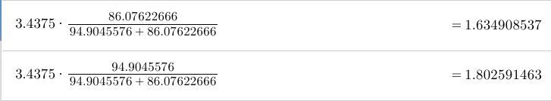

* **1.634908537A through 3900pF**
* **1.802591463A through 4300pF**